

VSSC Printer Order/ Removal Process

REVISION HISTORY SUMMARY

Date | Version | Changed By | Revision Summary
08/30/10 | 1.0 | James Robbins | Initial release of document
09/01/10 | 2.0 | James Robbins | Updated document with ‘Expedited’ order process
09/01/10 | 3.0 | Sheetal Swamy | Updated Page 17, to display ship date entry and changed document format
09/15/10 | 4.0 | Sheetal Swamy | Update to Page 3, paragraph 1 further detailing how to handle ‘Consultations without Hardware’
06/05 12 | 5.0 | Sheetal Swamy | Reviewed process and validating it as current. No additional changes made to the content.
10/25/12 | 6.0 | Advocate Team FY’13 | Updated existing process to include all scenarios in the case ASSC supports all JIT peripheral ordering
04/15/13 | 7.0 | Advocate Team FY ‘13 | Include Peripheral removal process
04/25/13 | 10.0 | Advocate Team FY’13 | Remove any original PID reference
05/10/13 | 11.0 | David Hernandez, Cindy Norton | Update with contact procedures and edits regarding ASSC employee number assignments
05/17/13 | 12.0 | David Hernandez,  Cindy Norton | Added Table of Contents and FSSC to ASSC Printer process flow.
05/20/13 | 13.0 | David Hernandez,  Cindy Norton | Updated End of Document ISO notation, changed title and saved name of document.
5/30/13 | 14.0 | David Hernandez,  Cindy Norton | Add details regarding systype and printer description match
6/18/13 | 15.0 | David Hernandez,  Cindy Norton | Edit reference of unscheduled/scheduled workloads instead of employee numbers
6/20/13 | 16.0 | David Hernandez,  Cindy Norton | Update verbiage on sub arf section
07/30/13 | 17.0 | David Hernandez,  Cindy Norton | Add Lost/Stolen Procedures. Reformatted and updated table of contents. Defined Laser Printer and changed 2 days on Lost/Stolen Procedures
08/29/13 | 18.0 | Advocate Team | Changed documentation to reflect that FSSC will send all supported upgrades to Austin.

Table of Contents

FSSC and ASSC Process Flow 4
How to Handle Printer/Scale Requests 6
Upgrade Procedures 8
Closing Out Nexus Upgrade Request 12
Drop Ship Procedures 14
Expedites and Multiples Orders 15
Lost/Stolen Procedures 20
Removals 23

FSSC and ASSC Process Flow

Original PID is submitted from sales:

- FSSC
  - Reviews request
    - FSSC will transfer all supported Upgrades to ASSC.(MAC Printers are not Supported)
    - FSSC will transfer Scan Gun orders to CIC.
  - Confirms there is an existing meter number on the account.

YES meter exists NO meter does not exist
- Create UPGRADE request.  - Save and keep request open (to continue visibility to request).  - Copy notes from original PID to UPGRADE request and include any additional instruction.  - Transfers UPGRADE request to HH Employee ID: designated for unscheduled workload.  - Change original PID On Hold Reason to Vendor.  - Update notepad with future date to check on status of request.  - UPGRADE request is completed by ASSC.  - FSSC project manages original request and completes original PID. | - FSSC consults on the ARF and determines correct solution.  - FSSC submits Sub-ARF for solution implementation per current processes.  - Include comments asking the ASSC to confirm the location for a printer order.  - FSSC changes On Hold Reason on original PID to Vendor.  - Update note-pad with future date to check for meter number.  - After the meter number exists, the FSSC creates an UPGRADE request to transfer to HH Employee ID: designated for unscheduled workload. Workload with the comments updated. Clearly notating necessary equipment, and if validation would still be necessary.
UPGRADE request is unable to be completed
- ASSC transfers UPGRADE request to FSSC.
- FSSC determines next steps and manages UPGRADE request and original PID accordingly.

- ASSC
  - Receives UPGRADE request
  - Follows current process to reach customer.
    - Verifies location and solution.
    - Confirms corresponding meter numbers exist for validated solution type by the customer (Proceed to Yes).
    - However, if the customer wants a different solution than that indicated on the Sub-ARF, proceed to NO. For example, if the Sub-ARF indicates FedEx.com is the solution, but the customer wants SW.)

YES corresponding meter number exists NO corresponding meter number does not exists
- Order peripherals based on printer order job aid.  - Provide Sales an email update per current process with the following Information.  - The number of printer/scales with the appropriate reference has been ordered with a requested ship date of xx/xx/xx.  - If there was a request for multiple printers the number of printers ordered is included for confirmation for the AE.  - If the CAHM process is used the CAHM reference. ID is copied and pasted into the AE correspondence email.  - ASSC completes request. | - ASSC provides customer the install information for the preferred solution (e.g. sends SW link/key code.). If Training is needed, the ASSC schedules that Training. ASSC notifies FSSC that new Sub ARF is required to complete solution training install prior to printer order.  - Changes the On Hold Reason to Awaiting Peripheral Order.  - Updates Notepad with future date to check for completed install.  - Once solution is implemented order printer.  - ASSC completes request.
ASSC is unable to reach the customer
- ASSC will update the notes
- Email FSSC action needed
- Transfer UPGRADE request to FSSC for further follow up.

How to Handle Printer/Scale Requests
Upgrade request type
- Contact Process
  - ASSC follows the current process to reach customer (2 attempts and an email as per current process).
    - If no response, transfer upgrade request to original CIC (SSC) employee number.
    - If the customer wants a different solution than that indicated on the Sub-ARF proceed to step b. For example, if the Sub-ARF indicates FedEx.com is the solution, but the customer wants SW.)
  - ASSC will update the notes.
  - Email FSSC action needed.
    - Transfer UPGRADE request to FSSC for further follow up.
- Validation
  - Meter number
    - FedEx.com: found on shipping label next to the word CAD or CTS Tool referencing User ID
      - If multiple fedex.com meter numbers exist and the meter number cannot be identified, select a fedex.com meter number and update the chgloc information. –See Change Location Procedures
    - ShipManager: found in title bar or on shipping label next to the word CAD
    - ShipManager Software child meter
We are unable to order peripherals on a child meter, please resubmit on the master acct. number xxx xxx xxx (which is provided by referencing back to the parent meter number in Amadeus)
- WEBXML-CSP and or WEBXML-XML represents a web integration or third party software meter number.

b. Type of printer
FedEx.com or CSP non doc tab labels
    - ShipManager Software with doc tab labels
    - Network printer
    - MAC: Windows partition ( Contact FSSC)
    - Mac CUPS driver configuration customer resources ( Contact FSSC)
c. Contact name
- Ship to address
(Cannot Change Drop Ship Address if using Ship Admin as shipping Solution)
Drop Ship – See Drop Ship Procedures
The Pioneer Request will have a new PID and “Upgrade” as the Request type.
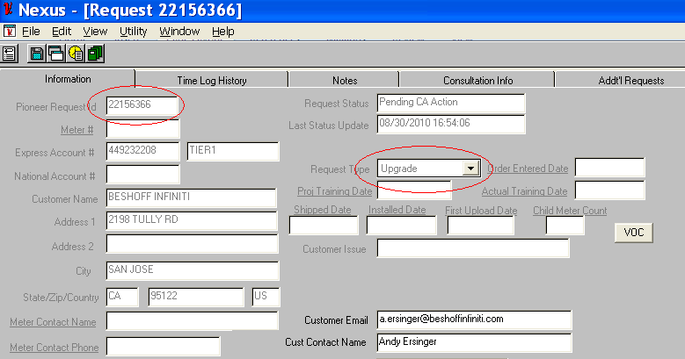
Once the “Upgrade” request is available, log in to Amadeus and confirm information is correct.
  - If information is correct, proceed to Upgrade Procedures.
  - If information is not correct, proceed to Change Location Procedures.

Upgrade Procedures
Once the “Upgrade” request is available, log in to Amadeus and proceed to inquire screen.
If you already have a cheers screen open you can just enter “Inquire” into the next screen field.
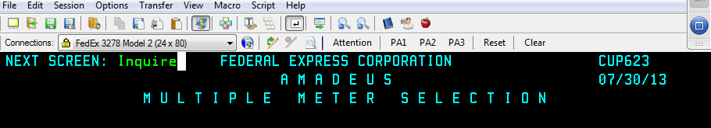
Enter the account number to view all available meter numbers.
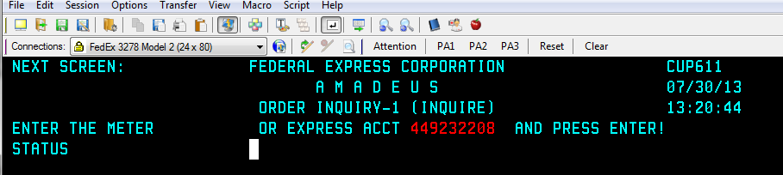
Select the meter number to be used for the upgrade. (enter an “x” next to the meter number to select).
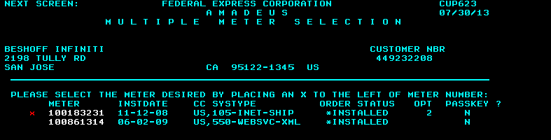

Confirm address is correct proceed to upgrade.

*If contact name needs to be updated use the CHGLOC screen in AMADEUS to update the correct contact name. - See Change Location procedures.
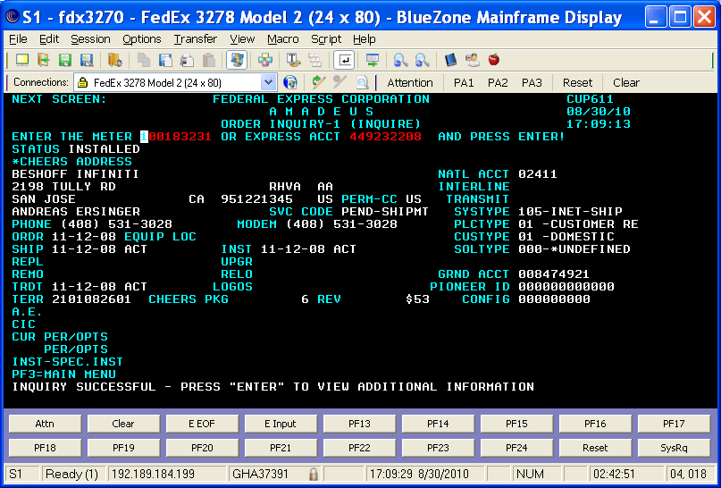
Type Upgrade in the NEXT SCREEN field and press Enter.
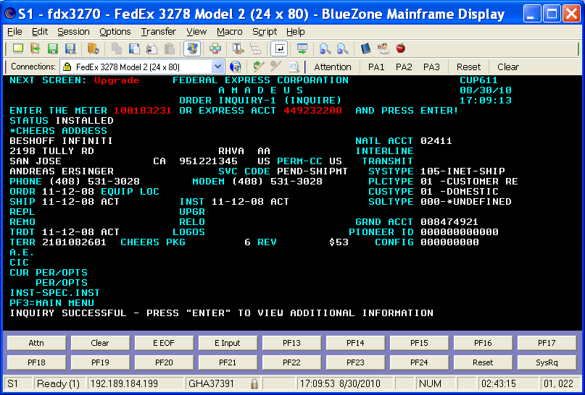

Enter the Pioneer ID from the Upgrade request and <enter>.
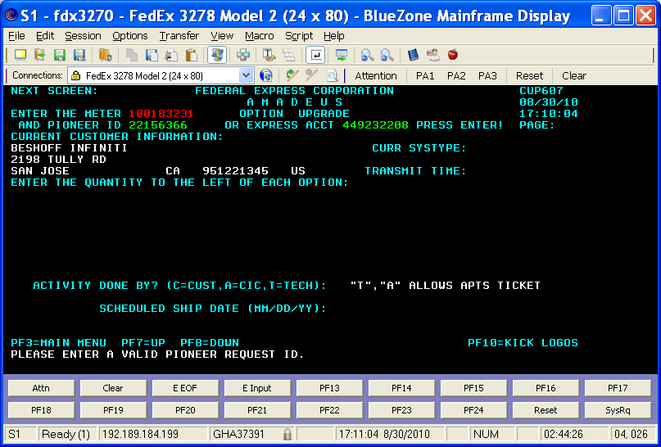
Enter “1” for either the Flat Top Scale and/or the Low Speed Zebra Printer. You can only order one scale and printer per meter number. Multiple printer or scale requests must each use a different meter number and will have to be submitted individually, but they can use the same pioneer ID from the Upgrade request.
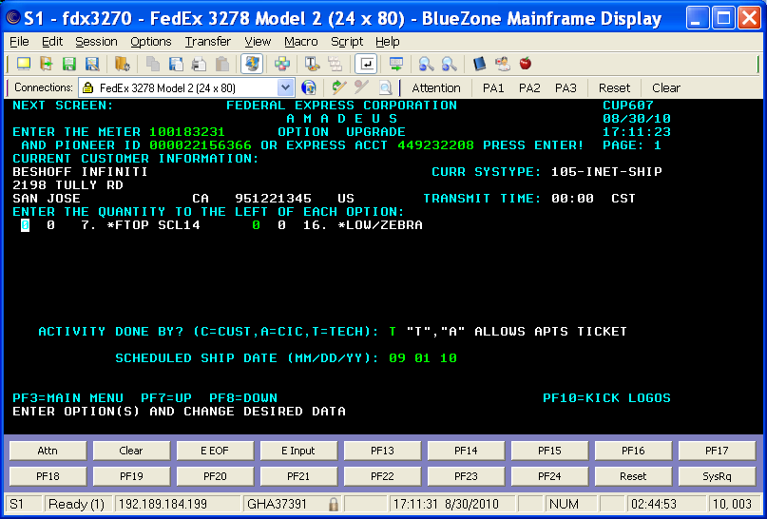
*If only one meter is available for a multiple peripheral order refer to the CAHM exception process
Select “A” as the activity done by, and choose the appropriate ship date and <enter>. By default the ship date will be listed as 2 business days out, and the printer will ship 2-day from that date. For next day delivery always enter a CAHM exception request.* (Orders must be submitted before 6:00pm Central time to be processed the same day). If processing order after 6:00pm CST, enter next day’s date as the ship date. Then hit <ENTER>.
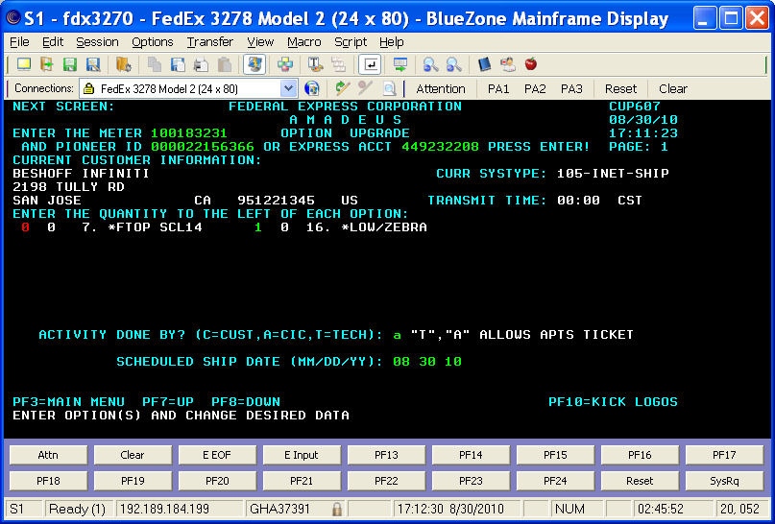
Enter “Y” to confirm your changes and <enter>.
Once the Upgrade has been successfully changed, press <F10> to Kick Logos
*The equipment will ship 2-day from the scheduled ship date

Once the transaction is sent you will see, “Logos transaction successfully sent for meter”.
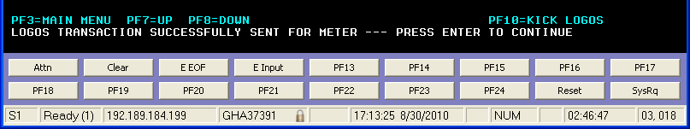

Closing Out Nexus Upgrade Request

On the Upgrade request you will need to click “Refresh Display”. Depending on how the account is assigned the assigned CIC and AE information may disappear. Provide sales email update per current process with the following Information.
*Note: You do not have to email the FSSC
  - The (number) printer/scale (appropriate reference) has been ordered with a requested ship date of xx/xx/xx.

  - If there was a request for multiple printers the number of printers ordered is included for confirmation for the AE.

    - If the CAHM process is used the CAHM reference. ID is copied and pasted into the AE correspondence email

Helpful Hint: If you send the email to the AE before Refreshing the display, you will not need to reenter their ID number.
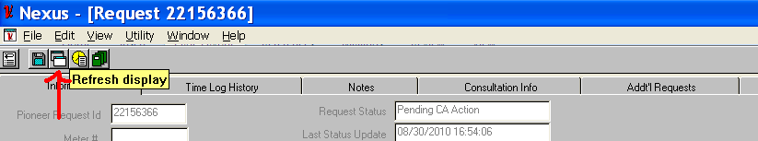

After refreshing the screen if the CIC field is blank on FedEx.com meters…
*Software requests will default to the original CIC (SSC) employee number
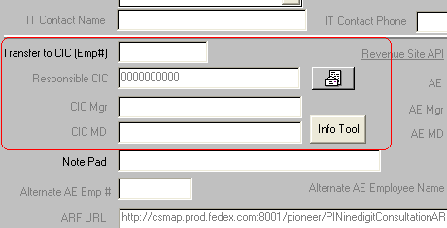
Enter your (ASSC) employee number and save. The request will now move from” Pending CA action” to ”Upgrade in Progress”.
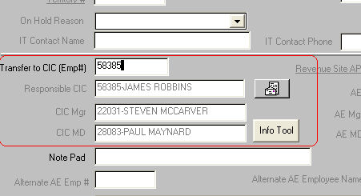

The printer/scale ordering process has now been completed.

Drop Ship Procedures
In Amadeus type in NEXT SCREEN: dropship
- Enter correct drop ship location information
- P for Permanent
- Enter to save
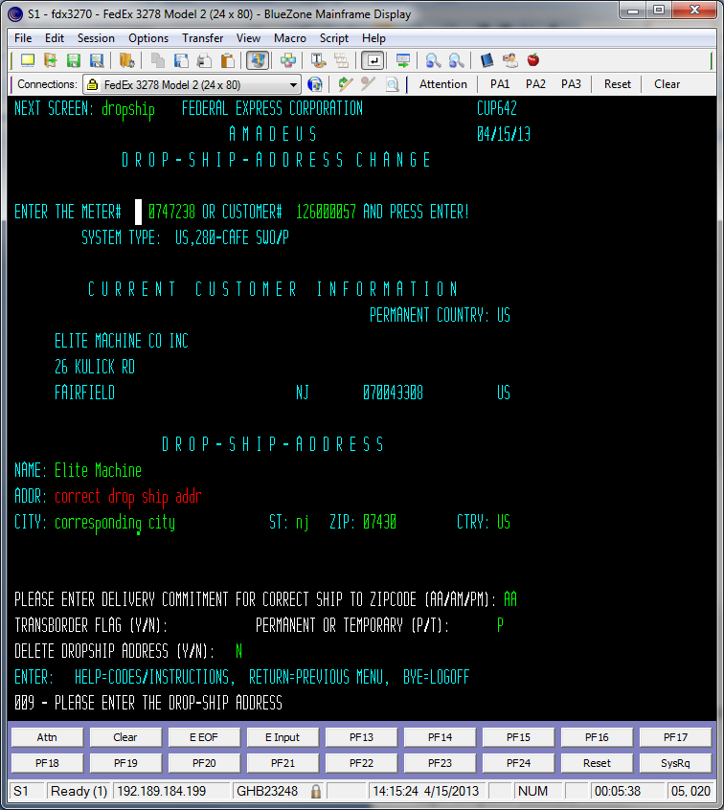

Expedites and Multiples Orders
Please remember Upgrades will ship *FedEx 2 Day (E2). If an expedite is necessary, you must order utilizing CAHM and request the order be expedited. Additionally, you need to utilize Cahms for multiple peripheral orders.
Log in to Amadeus and verify PID Contact/Address information matches.
*If contact/address is not correct see Change Location procedures.
If information is correct, proceed.
From the SSC home page select the CAHM icon. 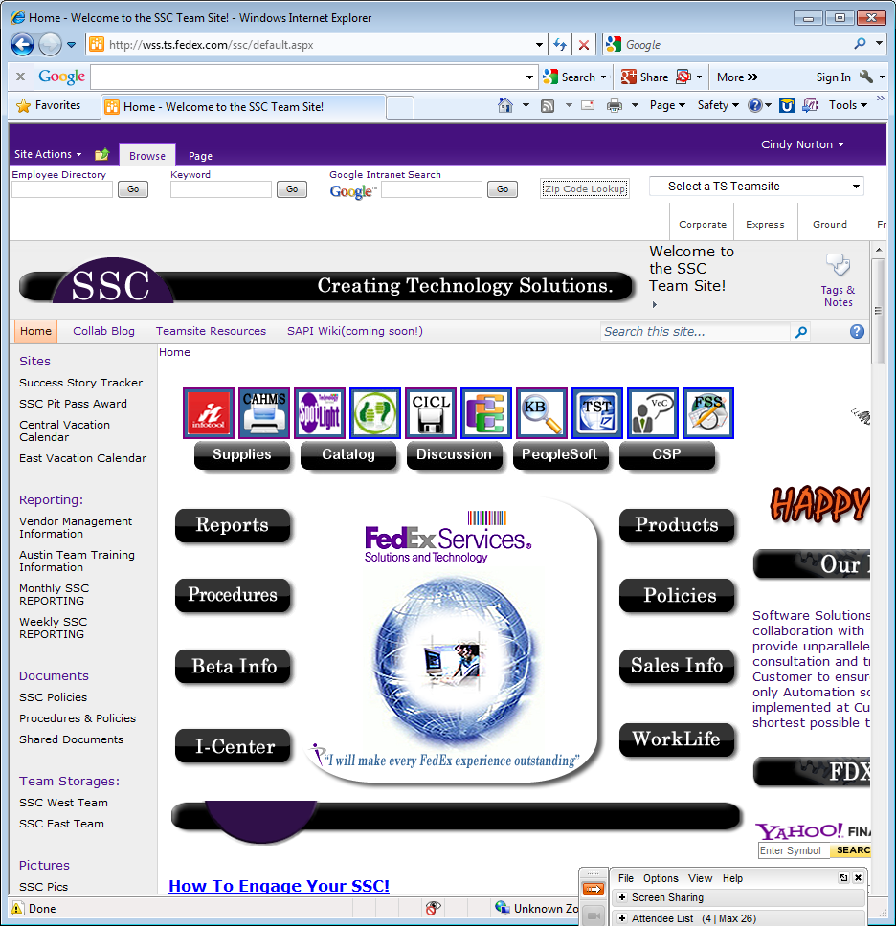
Log in using LDAP password
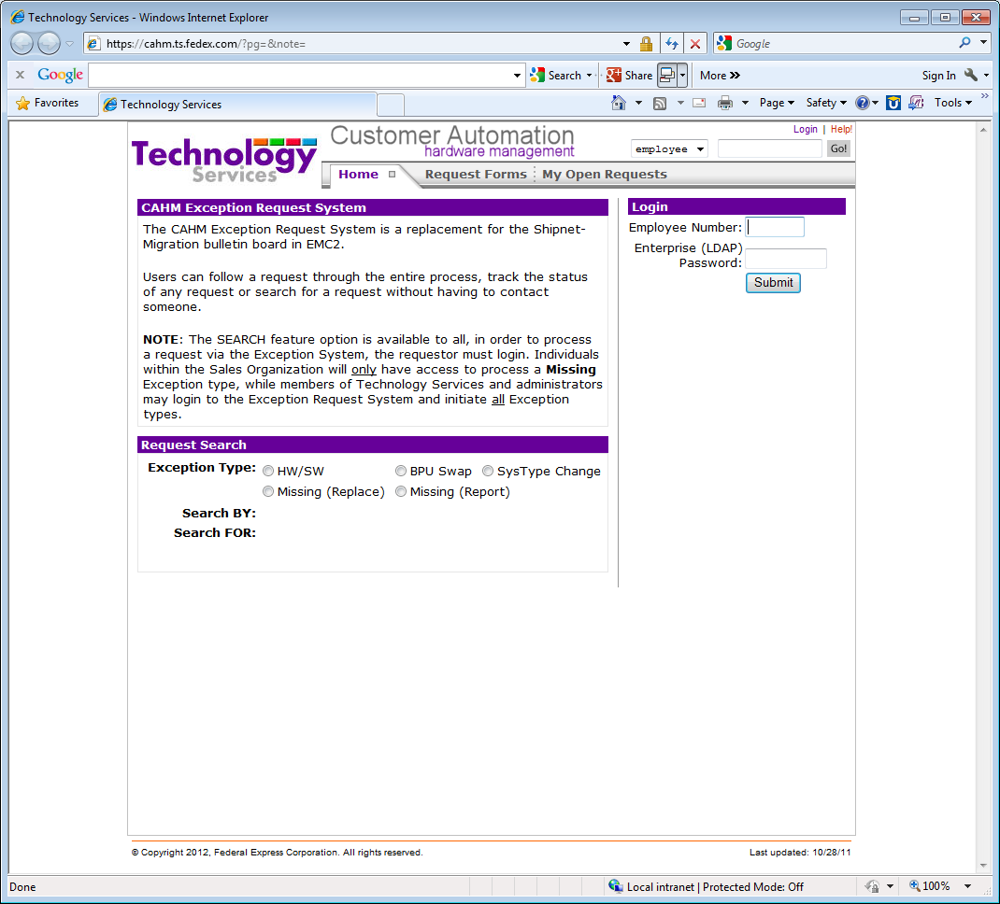
Select Request Forms
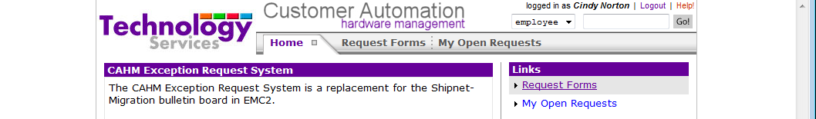

From the drop down menu select Hardware/Software
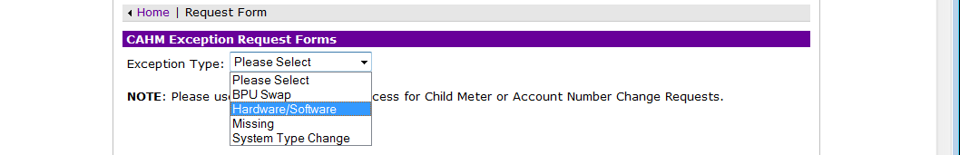
Enter the pioneer id from the upgrade request in Nexus
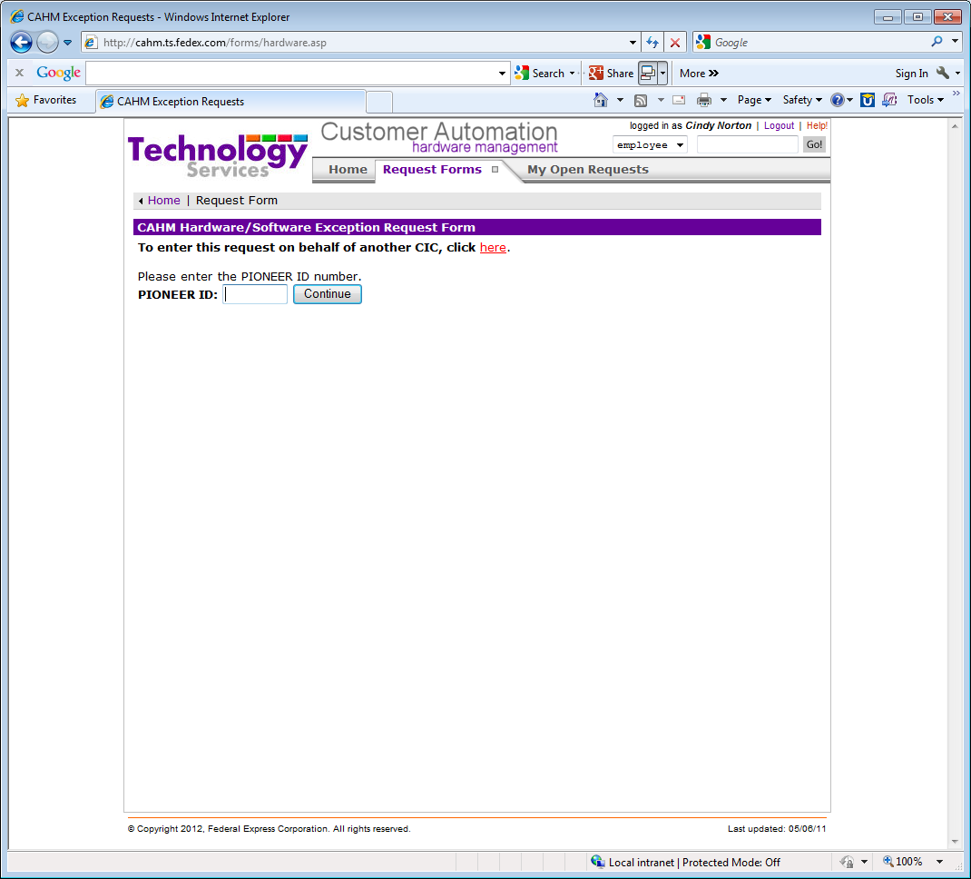

Enter all the highlighted fields:
- Ship date
- Expedite Check Box
- Select Meter Number
- LAN
- Installed by: TSR
- Equipment Location: Shipping
- Enter the number of peripherals requested(Multiple printer or scale orders)
- IF customer requests a “NETWORK printer” add comments: Provide Printer with Ethernet Card. Click Submit when Completed

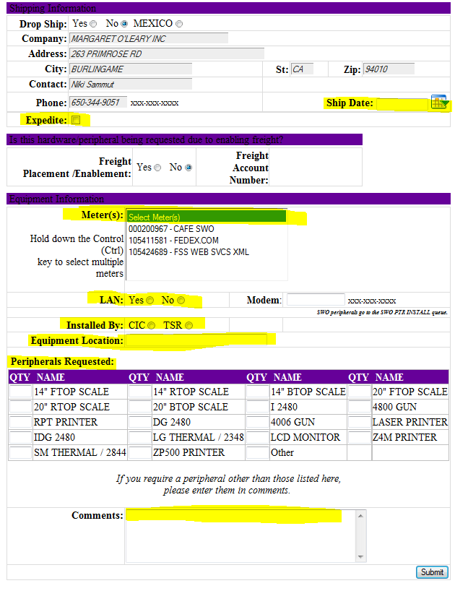
In Nexus Select on Hold Reason: CAHM exception submitted
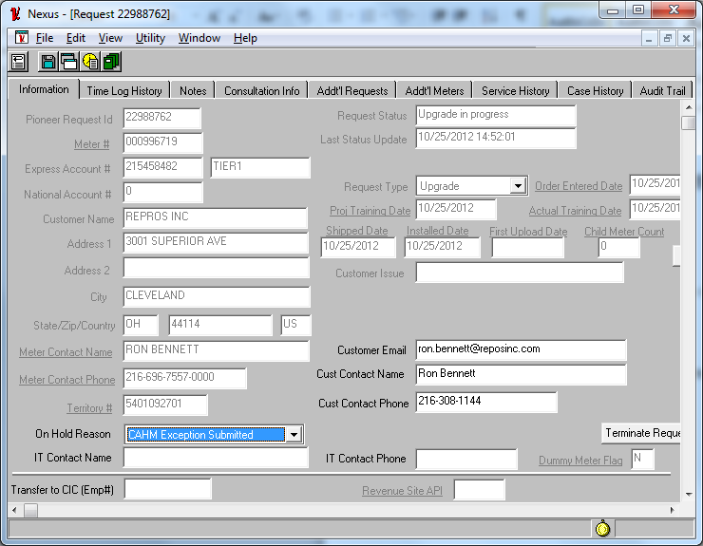
*In Notepad section: Enter 2 days from today’s date.

Lost/Stolen Procedures
From the SSC home page select the CAHM icon.
Log in using LDAP password

Select Request Forms

From the drop down menu select Missing.
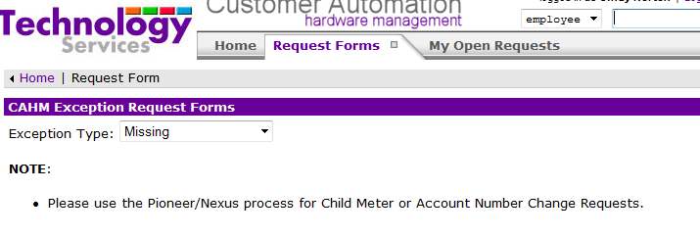
Enter Meter number:
- Sales should provide meter number in comments.
- If no meter then check Amadeus Inquire screen.
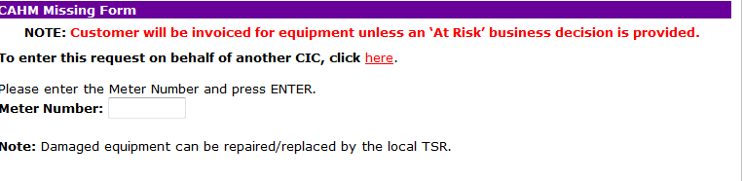
Check the report box and paste the sales comments from the ARF into the comments section.
Then Submit.
*After submitted update PID and notify sales “Lost/Stolen has been submitted”.
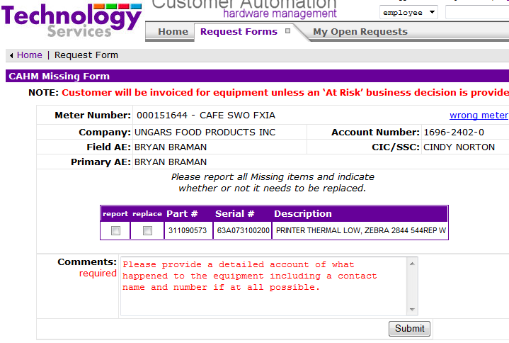

Removals

REMOVAL REQUEST
- AE completes & submits Consultation without Hardware ARF through Pioneer and provides comments with instruction to remove peripheral(s).
*No customer contact required by ASSC

ORDER ENTRY

- Verify in the INQUIRE SCREEN the type of peripheral currently in place 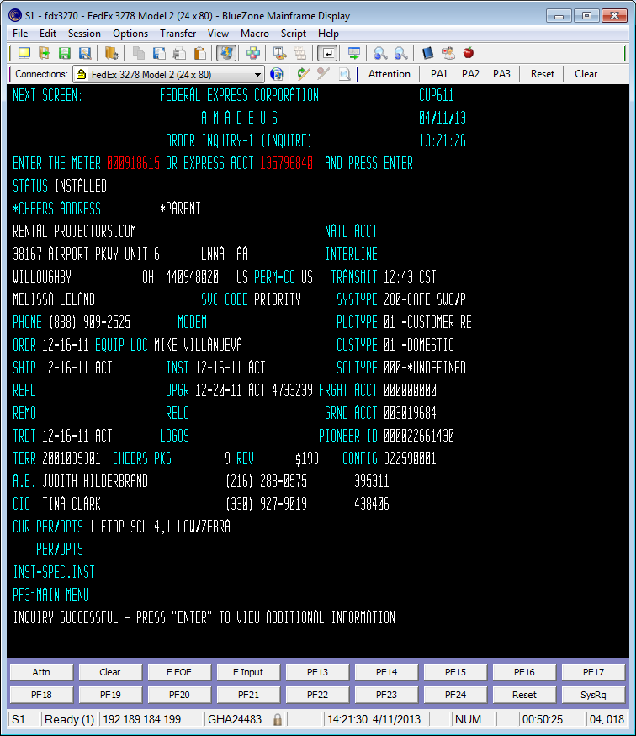
- Type REMOVAL in Next Screen:
- Enter the removal date minimum 5 working days out
- Tab to the corresponding equipment type i.e.: Low/Zebra use F8 to page down for additional printer types
- Enter the number of pieces to be removed
- If the contact name and phone number are different on the REMOVAL SCREEN, the ASSC will update to match the Pioneer Request.
- Enter the email address or type “shipping” in the location field in the REMOVAL SCREEN
- Done by CIC or TECH enter T
- Tab and place an X in front of the removal reason COMPLIANCE
- If there are specific comments provided by AE, enter into the COMMENTS and SPEC. INSTRUCTION sections
- Press ENTER
- Answer Y to confirmation

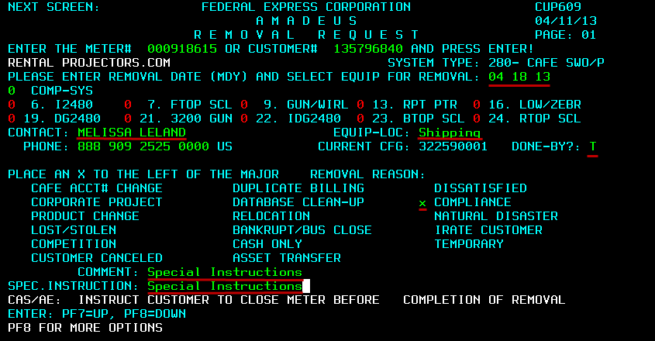

Completing Removal

- Email the AE a message via Nexus Email: “The Peripheral Removal has been entered with an expiration date of xx/xx. Command and Control will contact the customer to arrange the return”.

- Select Completed as the Completion code

- Save

END OF DOCUMENT

